Table of Contents
Good programs 2
User Interface 3
Documentation 4
Code Aesthetics 4
Naming Conventions 5
File layout 5
“Bad Smells” 6

Good programs
Test your programs properly to make sure that they don’t crash. Some of the things you will want to consider is…

1. | Checking for invalid input  If someone enters an input you weren’t expecting, does your program display an error message? Does it continue running and let the user select a new option?
2. | Easy to navigate  Even if you’re writing a text-based program, it is important to have it easy to use for any random user. Is your user interface clear? Does the user know when to input a choice, and what choices are available?

User Interface

1. | Text labels – use spaces between labels and variable data  Keep the user interface clean – when displaying labels for a variable, make sure you have spacing so that the label and the value don’t “bleed together”.
  Do | Don’t
  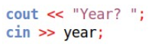 | 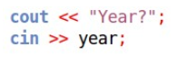
  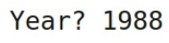 | 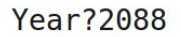
2. | Prompt the user for input  Don’t just use an input command without prompting the user for input – otherwise, for someone who doesn’t have access to the code, it won’t be clear what the program is doing or that it is expecting the user to input anything.
3. | Separate different phases of the program with whitespace, borders, or “clear screens”  Our programs will contain multiple features, usually accessed through a main menu. Make sure that the main menu and different program sections don’t “bleed together” by separating them with whitespace, borders, or clearing the screen.
  Do | Don’t
  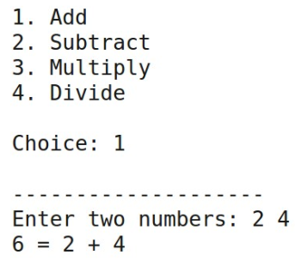 | 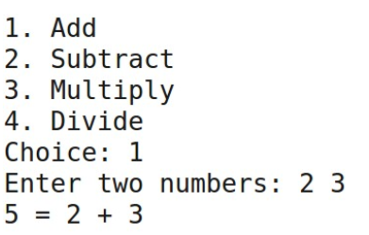

Documentation
4. | Self-documenting code via clear variable, function, and class names  In the real world, comments are rarely written, and rarely useful because code in an existing product can change so much. This is why it is important to have self-documenting code. Just by reading your program code, it should be clear what is going on.  To do this, make sure your variable, function, and class names are clear and descriptive. Separate chunks of functionality into modular parts – one function per task.

Code Aesthetics
1. | 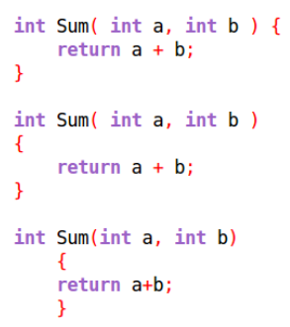  Stay consistent  If you prefer your curly braces on the same line as your if statements and function headers, that’s fine – just keep it consistent. Choose one style or another!  (Same for whitespace).
2. | Add whitespace between sections  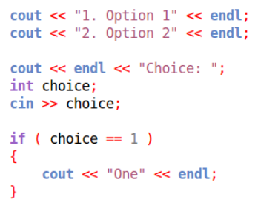  Make code easy to read – separate out chunks of related code by category or like-purposes.
3. | 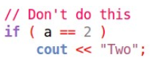  Use curly braces  Sure, you could leave off the curly braces of a code block if the block is only one line, but don’t. It’s ugly, it is a pain to maintain, and it can lead to logic errors as your codebase grows.
4. | 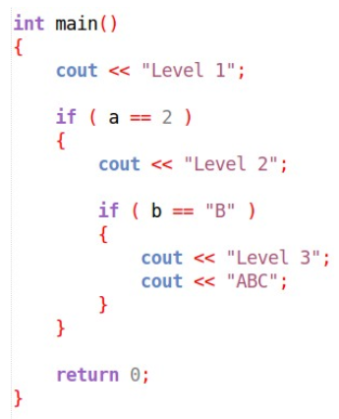  Indent.  You should indent inside any codeblock. A codeblock is contained within curly braces { }, such as when you’re writing an if statement, function, while loop, for loop, etc.  Everything at the same level should also be indented the same.  Many IDEs will auto-format for you, so make sure you indent early and often!

Naming Conventions
Every language has its own naming conventions, so it is good to be familiar with conventions.
(if you prefer using underscores to camelCase, go ahead and use that.)

1. | Variable names: camelCaseWithLowerFirstLetter
2. | Single-letter variable names: Only for iterators/for loops, or math formulas; i, j, k, x, y, z, ...
3. | Function names: CamelCaseUpperFirstLetter
4. | Class names: CamelCaseUpperFirstLetter
5. | Constant variables: ALL_UPPER_CASE

File layout

1. | .cpp and .hpp  Class declarations should have their own .hpp file, with all the function definitions in a .cpp file.

“Bad Smells”
A “Bad Smell” is a term given for code that is stinky and could stand to be cleaned up…

1. | Duplicate code  Have a bunch of code that is too similar? Can it be reduced to only occurring once, perhaps by extracting that code into its own function?

